SendGrid Email with Attachment Step

Objective

SendGrid is a cloud-based SMTP provider that allows you to send email without having to maintain email servers. SendGrid manages all of the technical details, from scaling the infrastructure to ISP outreach and reputation monitoring to whitelist services and real-time analytics.

UI

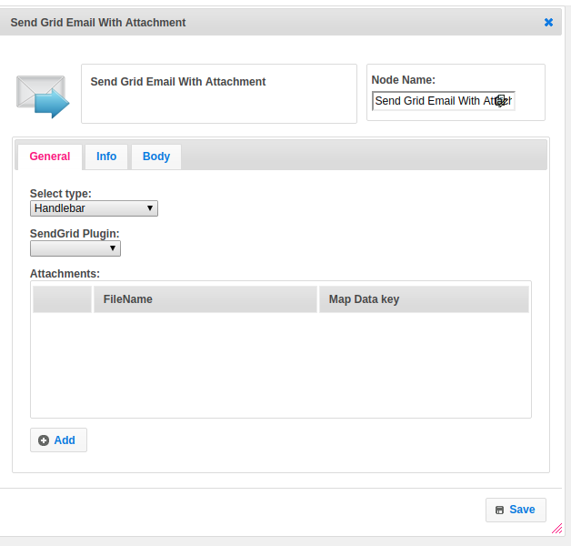

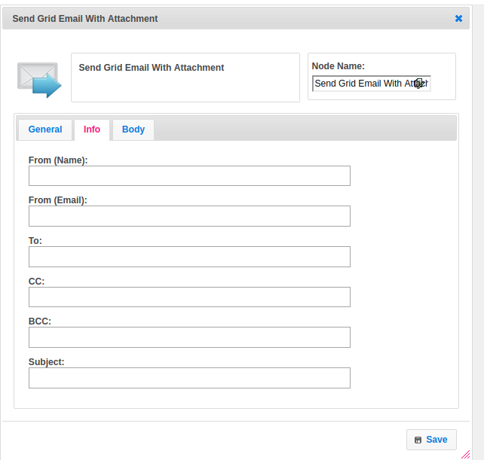

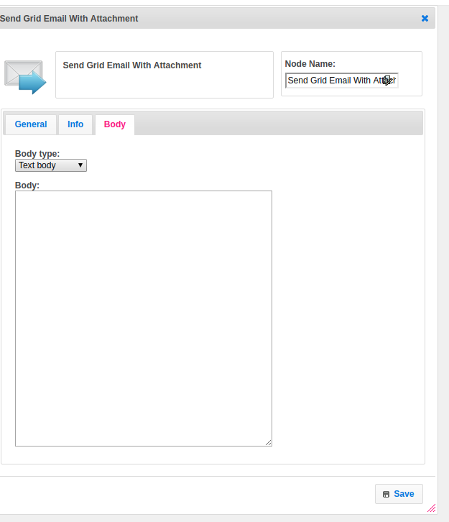

## Attachment

|  |  |
| --- | --- |
| **Attributes** | **Description** |
| **1. Select Type** | Select Type used to set the value type.  Value types are two types.  1.hb-HandleBars  2.ftl-Freemarker Template Language. |
| **2. SendGrid Plugin** | Select the plugin. It contains the plugin configuration information. To get more information about plugin please refer the Plugin Dependence block. |
| **3. Attachments** | Attachment is a list. It contains a list of attachments. |
| **4. From (Name)** | Name of the sender. |
| **5. From (Email)** | From mail address. |
| **6. To** | Recipient mail address |
| **7. CC** | CC(Carbon Copy ) mails. |
| **8. BCC** | BCC(Blind Carbon Copy ) mails. |
| **9. Subject** | The subject represents the mail subject |
| **10. Body Type** | Body_type is having the type of body.  Supports two types of data  1.text/plain  2.text/HTML |
| **11. Body** | In the body, we can pass body data. |

## Executor Description:

Get the SendGrid plugin information from the context object.Call the SendEmail method by passing the from_email,from_name,to_email,cc_email,bcc_email,subject,body_type,body and attachment.Call the send mail method in SendGridPluginExecutor class by passing SendgridEmail object and map. Build the Request by using Request. Builder class. Create an object for OkHttpClient class. Call execute method in OkHttpClient.newCall by passing the request object. Create SendGridResponse object by calling SendGridResponse class one-arg constructor by passing the response object. If the response is successful then return success else failure.

## Plugin Dependencies:

|  |  |
| --- | --- |
| **Attributes** | **Description** |
| **1. Plugin Config Name** | Name of the plugin |
| **2. API Key** | This endpoint allows you to retrieve all API Keys that belong to the authenticated user.  The API Keys feature allows customers to be able to generate an API Key credential which can be used for authentication with the SendGrid v3 Web API. |

## Resource:

Please find the below link to get more information.

<https://sendgrid.com/docs/api-reference/>